**OLABISI ONABANJO UNIVERSITY**

College of Engineering & Environmental Studies,

Faculty of Engineering

Ibogun Campus.

**MECHANICAL ENGINEERING DEPARTMENT**



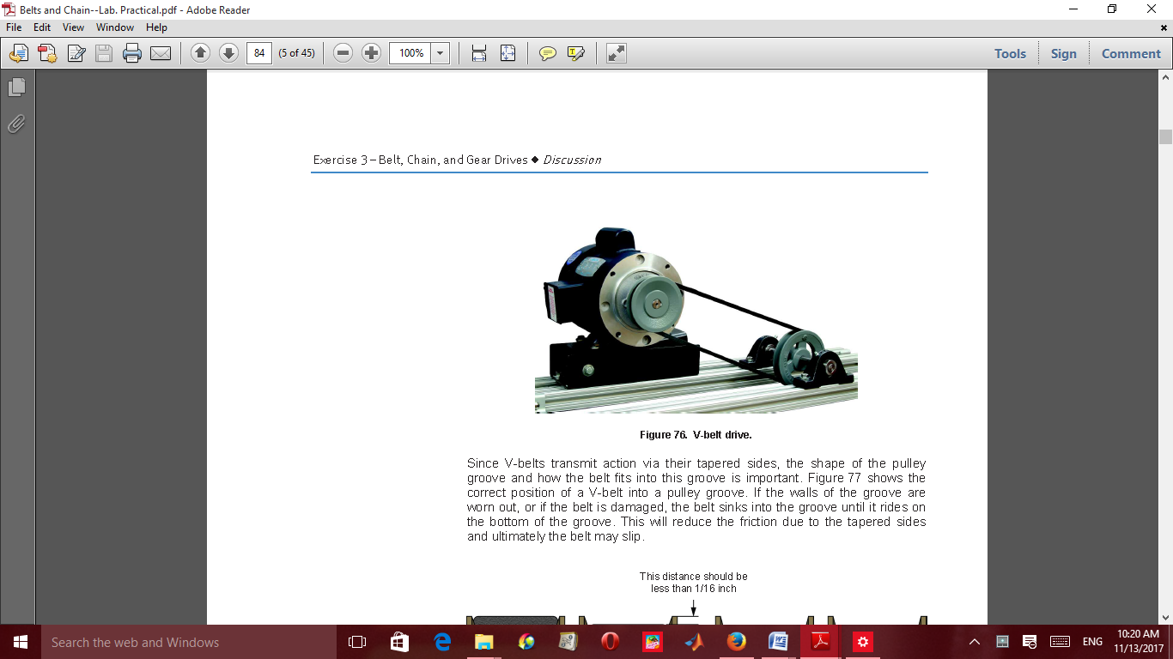 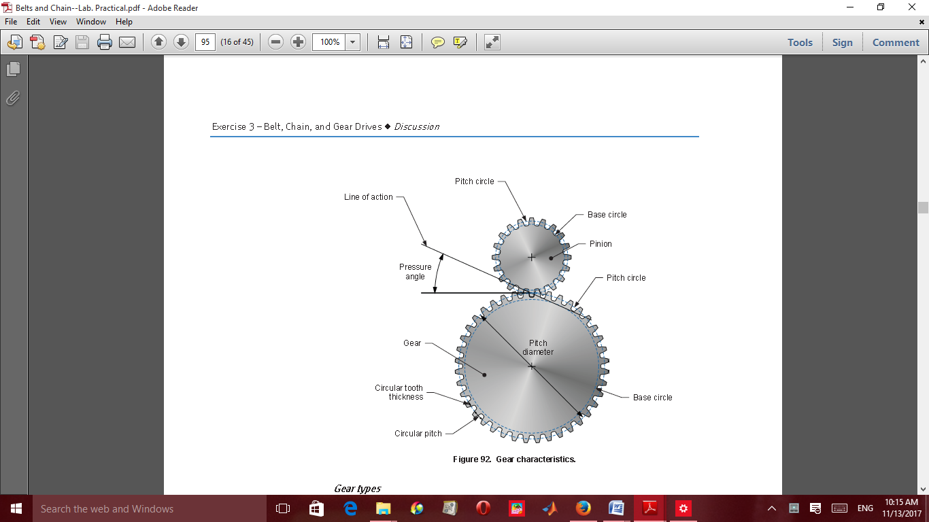

**MECHANICS OF MACHINES I**

**LABORATORY MANUAL**

**300 LEVEL**

**NAMES…………………………………………………………………………………..**

**MATRIC. NO. :……………………………… LEVEL: ………………………………**

**DEPT.: ………………………………………. GROUP NO: …………………………**

**COURSE:……………………………………. CODE: ………………………………..**

**DATE:…………………SESSION:………………SIGNATURE…………………….**

**MECHANICS OF MACHINES PRACTICALS (MEG 301)**

**Table of contents**

Experiment 1 Belt drives performance characteristics

Experiment 2 Chain drives performance characteristics

Experiment 3 Gear Characteristics Experiment

Experiment 4 Static and dynamics balancing

Experiment 5 Porter governor experiment

**BELT, CHAIN and GEAR DRIVES**

**Objectives**

At the end of the study, the students should be able to

* Name the different types of belt and chain drives
* Explain what gear train, gear drives and gear boxes are
* Identify signs of wear on a belt or chain drive
* Apply the knowledge of drives and mechanical parts to remove, inspect and install a chain or a belt
* Explain the importance of lubrication.

**Introduction**

**Power Transmission**

Power transmission machines uses chains, gears or belts. Generally, chain is an economical part of power transmission machines for low speeds and large loads. However, it is also possible to use chain in high speed conditions like automobile engine camshaft drives. This is accomplished by devising a method of operation and lubrication.

Basically, there are lower limits of fatigue strength in the gear and the chain, but not in the belt. Furthermore, if a gear tooth breaks, the gear will stop at the next tooth. Therefore, the order is gear better than chain and chain better than belt in the aspect of reliability.

In most cases:

(1) An increase in gear noise indicates that the end of the service life is near.

(2) You will know that the chain is almost at the end of its life by wear elongation or an increase in vibration caused by wear elongation.

(3) It is difficult to detect toothed-belt life without stopping the machine and inspecting the belt carefully.

It is possible to decrease gear noise by adjusting the gears precisely or by adapting the drive to a helical or double helical gear. Both of these are expensive and thrust load may occur with the use of helical gears.

Chain is more suitable to long-term continuous running and power transmission with limited torque fluctuation. Gears are more fit to reversing or intermittent drives.

The greater the shaft center distance, the more practical the use of chain and belt, rather than gears.

Generally, under the same transmission conditions, the cost of toothed belts and pulleys is much higher than the cost of chains and sprockets.

See the following features and points of notice about roller chain transmission.

Features of Chain Drives:

1. Speed reduction/increase of up to seven to one can be easily accommodated.

2. Chain can accommodate long shaft-center distances (less than 4 m), and is more versatile.

3. It is possible to use chain with multiple shafts or drives with both sides of the chain.

4. Standardization of chains under the American National Standards Institute (ANSI), the International Standardization Organization (ISO), and the Japanese Industrial Standards (JIS) allow ease of selection.

5. It is easy to cut and connect chains.

6. The sprocket diameter for a chain system may be smaller than a belt pulley, while transmitting the same torque.

7. Sprockets are subject to less wear than gears because sprockets distribute the loading over their many teeth.

Points of Notice:

1. Chain has a speed variation, which is caused by the polygonal effect of the sprockets.

2. Chain needs lubrication.

3. Chain wears and elongates.

4. Chain is weak when subjected to loads from the side. It needs proper alignment.

If a substance, like grease or oil decreases the coefficient of friction, when it gets onto the belt contact surface, the belt cannot deliver the required tension.

**Sprockets**

(1) Tooth shapes are either ANSI- or BS-type. Currently the BS-type is used more frequently.

(2) Automotive engines are produced on a large scale. The sprockets for both the crankshaft and the camshaft are mass-produced from sintered metal.

**Selection and Handling**

(1) These chains are used with chain guides, levers, and tensioners to reduce chain elongation, vibration, and noise.

(2) Generally, the chains are selected according to the transmission torque, small-sprocket speed, and the layout. In mid- to high-speed transmission, vibration and lubrication must also be considered.

(3) These chains need forced lubrication.

**EXPERIMENT 1**

**Title:** Belt drives performance characteristics

**Objective(s)**: The student should be able to:

i. identify the types of belts and pulleys,

ii. state their application and maintenance

**Apparatus/materials:** Belts of various types, different types of pulleys

**Theory:** Belts are used in transmission of mechanical power in machines and equipment through friction generated on pulleys. Belt drives applications include:

• Belt drives are used when large distances between shafts make gears impractical or when designated speed is too high for chain drives.

• Belts are used with pulleys or sheaves to transmit power.

• Belts require tensioning and are prone to slip under high loads.

Belts are used in various machines and equipment to generate mechanical power

Consider when the pulley is fixed and the left side of the belt is loaded with tension (*T0*), the force needed to pull the belt down to the right side will be:

For example, *T0* = 100 N: the coefficient of friction between the belt and pulley, μ = 0.3; the wrap angle θ = (180°).

*T1* = *T0* * 2.566 = 256.6 N

In brief, when you use a flat belt in this situation, you can get 256.6 N of drive power only when there is 100 N of back tension. For elements without teeth such as flat belts or ropes, the way to get more drive power is to increase the coefficient of friction or wrapping angle. If a substance, like grease or oil, which decreases the coefficient of friction, gets onto the contact surface, the belt cannot deliver the required tension. The belt attached to a motor and pulley transmitting mechanical power is shown in Figure 1.1



Figure 1.1: A belt attached to a motor transmitting power

V-belts transmit action through their tapered groove sides. The shape of the groove pulley and the way the belt is fitted to the groove is important. The figure above shows the correct position of a V-belt into a pulley groove. If the walls of the groove are worn out or damage, the belt sinks into the groove until it rides on the bottom of the groove. This will reduce the friction due to the tapered sides and ultimately the belt may slip.

V-belts are standardized, it dimensions, designation and wear can be determined by using a V-belt and sheave guage.

Belt drives applications are shown in the machine in Figures 1.2.

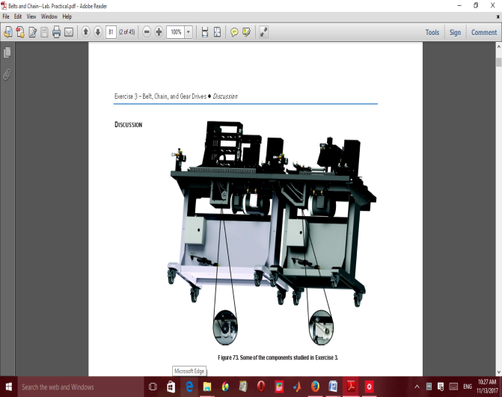 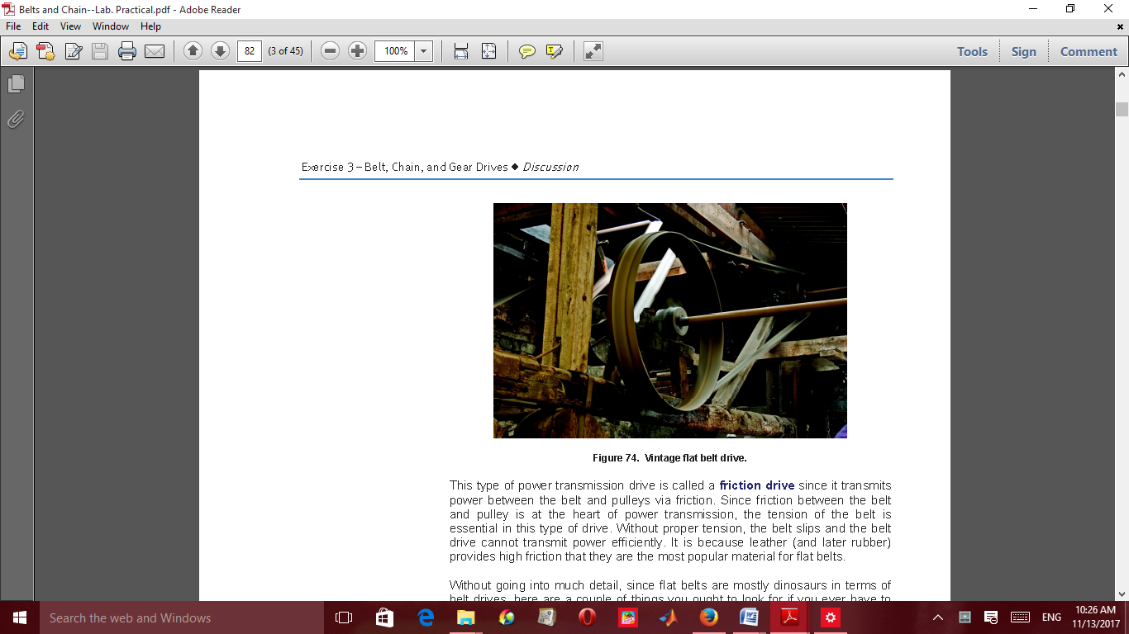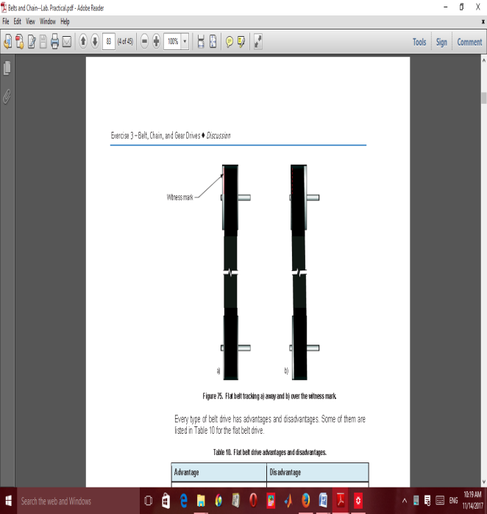 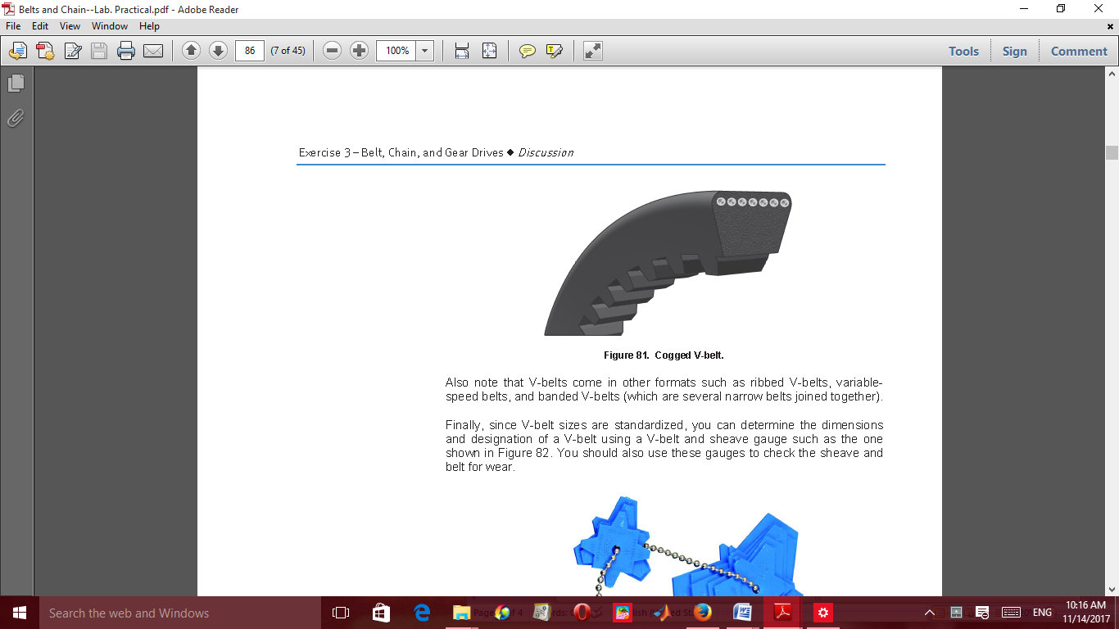 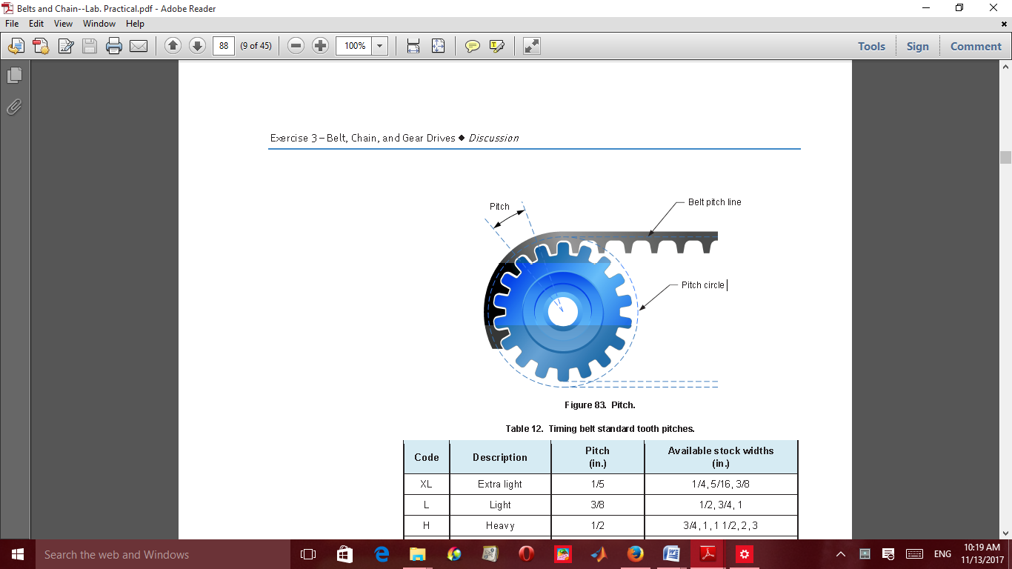

A B C D E

Figure 1.2 (A-E) Types of Belt drives applications

**Diagram**

Types of belts

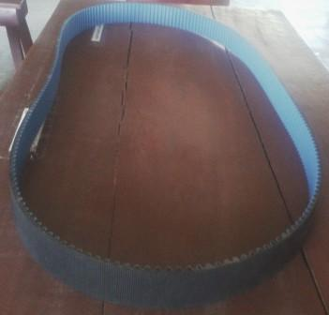 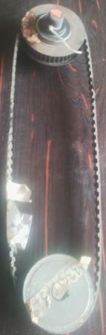 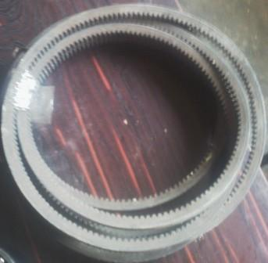 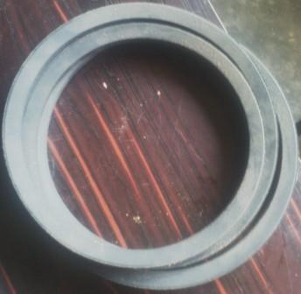

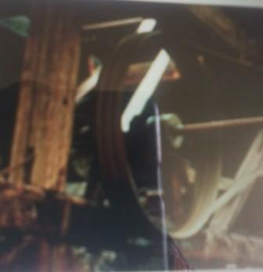 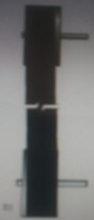 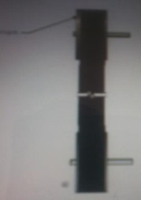

Figure 1.3. Types of belts

Types of pulleys

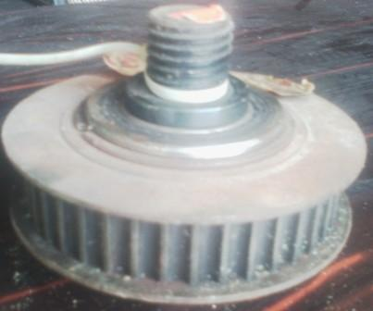 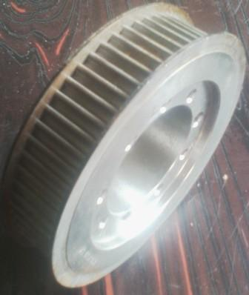 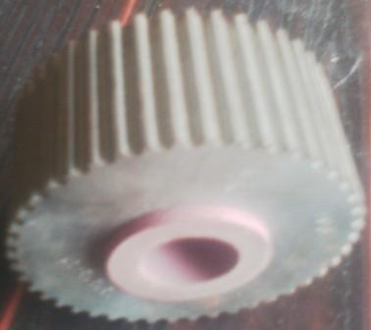

Figure 1.4 Pulleys

**Procedures**

i. Examine the belts shown in figure 1.3

ii. Examine the pulleys shown in figure 1.4

Exercises

1. Identify and name each of the belts examined in figure 1.3.

2. Identify and name the pulleys examined in figure1.4.

3. State the application of belts mentioned in Q1.

4. Sketch a groove pulley and a serrated pulley.

5. What is the difference between groove pulley and serrated / saw-toothed pulley?

6. What is the major advantage of belt drives over chain drives?

7. What is the effect of grease and oil on the belt efficiency?

***PRACTICAL REPORT***

***EXPERIMENT: 1***

***Title:………………………………………………………………………………………………***

Aims/Objectives:

………………………………………………………………………………………………….......................................................…..................................................................................................................................................................……………………………………………………………………………………………………........................................................................................................................................................................................................................……………………………

***Equipment/Apparatus/Materials:***

***………………………………………………………………………………………………………………………………………………………………………………………………………………………………………………………………………………………………………………***

***Theory:***

………………………………………………………………………………………………….......................................................…..................................................................................................................................................................……………………………………………………………………………………………………........................................................................................................................................................................................................................……………………………

………………………………………………………………………………………………….......................................................…..................................................................................................................................................................……………………………………………………………………………………………………........................................................................................................................................................................................................................……………………………

………………………………………………………………………………………………….......................................................…..................................................................................................................................................................……………………………………………………………………………………………………........................................................................................................................................................................................................................……………………………

………………………………………………………………………………………………….......................................................…..................................................................................................................................................................……………………………………………………………………………………………………........................................................................................................................................................................................................................……………………………

………………………………………………………………………………………………….......................................................…..................................................................................................................................................................……………………………………………………………………………………………………........................................................................................................................................................................................................................……………………………

………………………………………………………………………………………………….......................................................…..................................................................................................................................................................……………………………………………………………………………………………………........................................................................................................................................................................................................................……………………………

***…………………………………………………………………………………………………………………………………………………………………………………………………………………………………………………………………………………………………………………………………………………………………………………………………………………………………………………………………………………………………………................................................................................................................................................................……………***

***Diagram(s):***

1. Identify and name each of the belts examined in figure 1.3

………………………………………………………………………………………………….......................................................…..................................................................................................................................................................…………….………………………………………………………………………………………........................................................................................................................................................................................................................……………………………

2. Identify and name the pulleys examined in figure1.4

........................................................................................................................................................................................................................................................................................................................................................................................................................................................................................................................

........................................................................................................................................................................

3. State the application of belts mentioned in Q1

................................................................................................................................................................................................................................................................................................................................................

........................................................................................................................................................................................................................................................................................................................................................................................................................................................................................................................

.................................................................................................................................................................................................................................................................................................................................................................................................................................................................................................

4. Sketch a groove pulley and a serrated pulley

Diagram:

5. What is the difference between groove pulley and serrated/ saw-toothed pulley?

………………………………………………………………………………………………….......................................................…..................................................................................................................................................................……………………………………………………………………………………………………........................................................................................................................................................................................................................……………………………

………………………………………………………………………………………………….......................................................…..................................................................................................................................................................……………………………………………………………………………………………………..............................................................................

6. What is the major advantage of belt drives over chain drives?

……………………………………………………………………………………………………………………………………………………………………………………………………………………………………………………………………………………………………………………………………………………………………………………………………………………………………….......................................................…..................................................................................................................................................................……………………………………………………………………………………………………........................................................................................................................................................................................................................……………………………

7. What is the effect of grease and oil on the belt efficiency?

………………………………………………………………………………………………….......................................................…..................................................................................................................................................................……………………………………………………………………………………………………........................................................................................................................................................................................................................……………………………

………………………………………………………………………………………………….......................................................…..................................................................................................................................................................……………………………………………………………………………………………………........................................................................................................................................................................................................................……………………………

………………………………………………………………………………………………….......................................................….........

Precaution(s):

………………………………………………………………………………………........................................................................................................................................................................................................................……………………………

………………………………………………………………………………………………….......................................................…..................................................................................................................................................................……………………………………………………………………………………………………........................................................................................................................................................................................................................……………………………

………………………………………………………………………………………………….......................................................…..................................................................................................................................................................……………………………………………………………………………………………………..............................................................................

Reference(s):

………………………………………………………………………………………………….......................................................…..................................................................................................................................................................……………………………………………………………………………………………………........................................................................................................................................................................................................................……………………………

………………………………………………………………………………………………….......................................................…..................................................................................................................................................................……………………………………………………………………………………………………............................................................................

**EXPERIMENT 2**

**Title:** Chain drives performance characteristics

**Objective(s):** The student should be able to

i. identify the types of chains and sprockets,

ii. state their application and maintenance

**Apparatus/materials:** Chains of various types, different types of sprockets

**Theory:**

Chains are used in transmission of mechanical power in machines and equipment through sprockets attached to the shaft. Applications are:

• Chain transmits power through interlocking links wrapping on a sprocket.

• Chain drives have a high load capacity.

• They can be used to transmit power or impart timed linear motion.

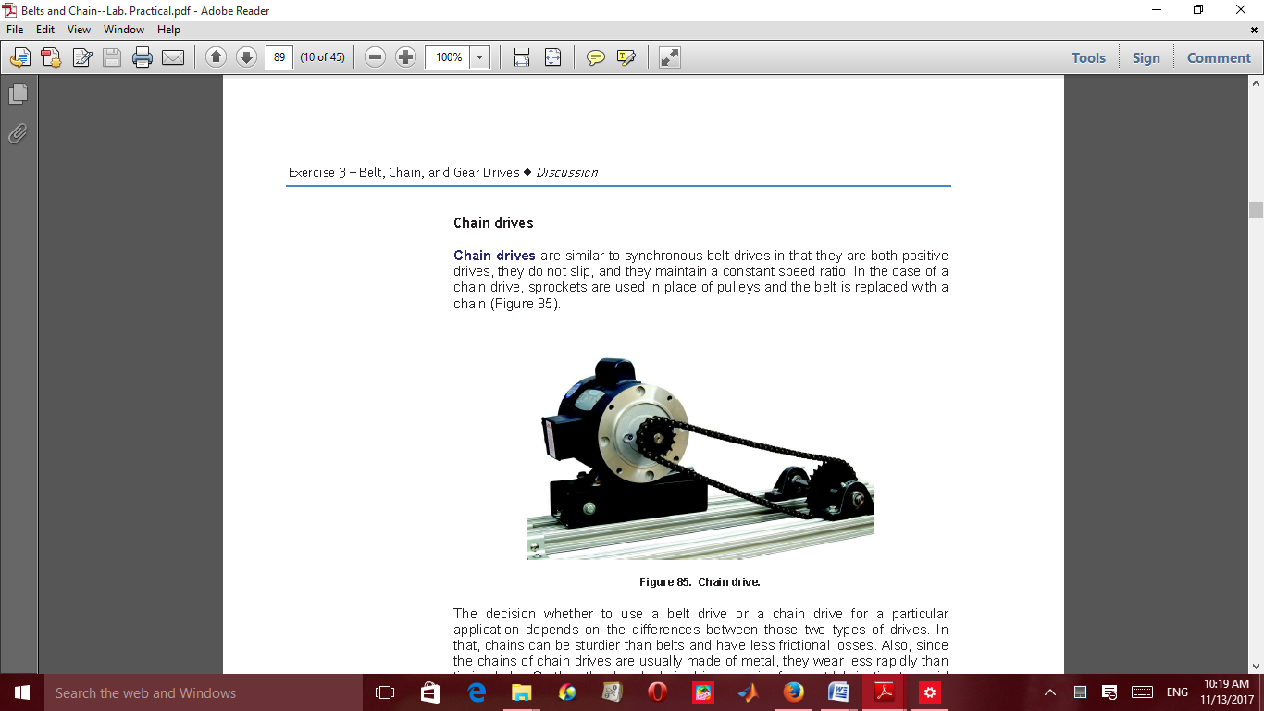

Figure 2.1: Chain drive

Chain drives are positive drives which are similar to synchronous belt drives. It does not slip and maintain a constant speed ratio. Sprockets and chain are used in chain drives instead of pulley and belt used in the belt drives.

Types of chain are: roller chain, rollerless chain and silent chain.

Advantage of silent chain over the others is that, it drives can support loads that exceed the capacity of roller chain drives

**Sprockets:**

Sprockets and shafts used in chain drives must be accurately aligned. The major two misalignments are axial and parallel misalignment. When the chain angle is not the same with sprocket angle, there will be axial misalignment. Also, when the chain is not on the same horizontal plane with that of sprocket, there will be horizontal misalignment.

Lubrication of the chain is very necessary to obtain the expected performance.

Chain attachments:

The diagram of chain attachments are shown in the diagrams in figure 2.2.

 

  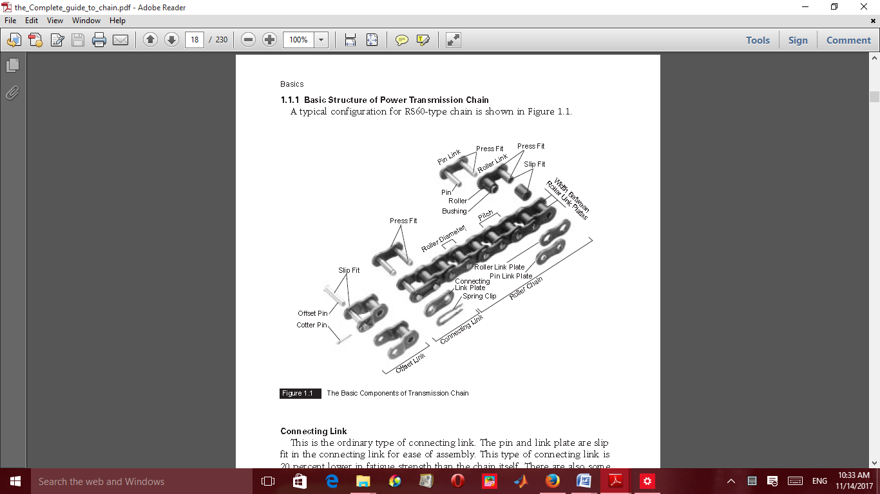 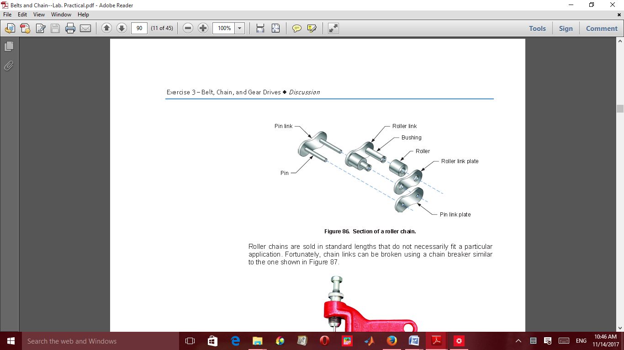 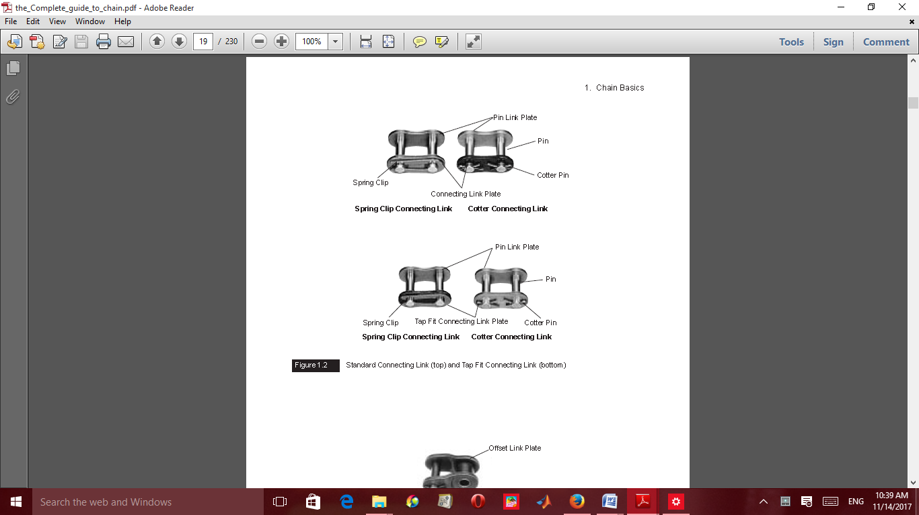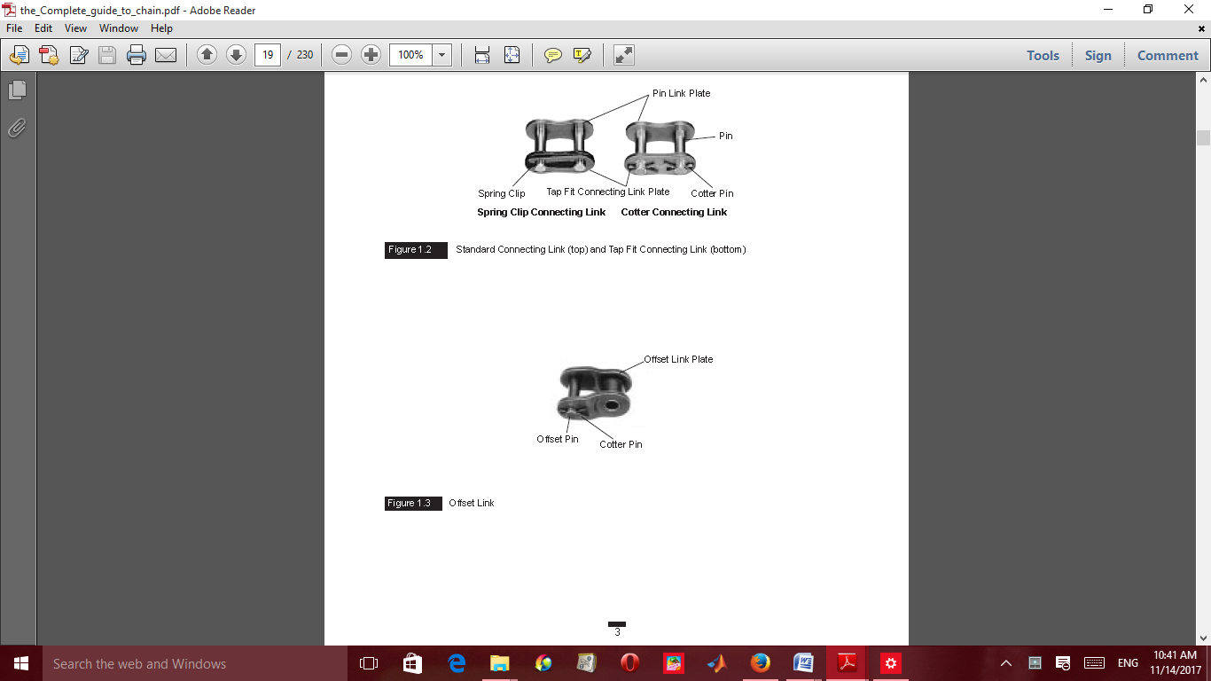  

Figure 2.2: Chain attachments

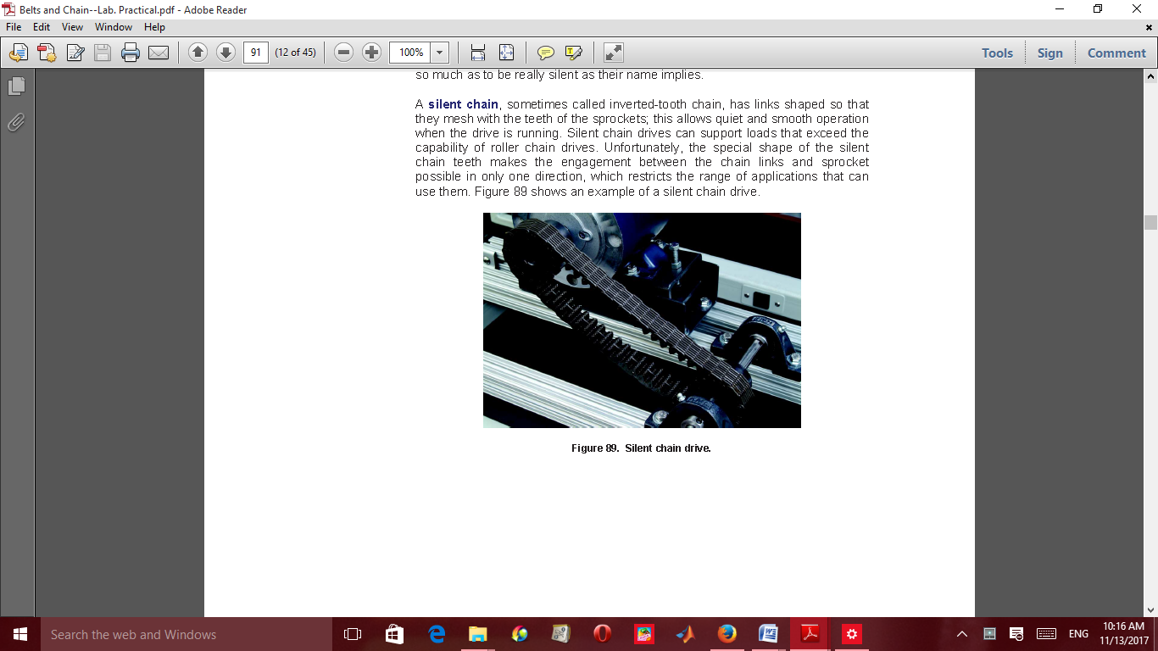 

A Figure 2.3: Silent chain B



Figure 2.4: Sprockets

**Procedure**i. Study and examine the chains in Figure 2.3.

ii. Study and examine the sprocket shown in Figure 2.4.

**Exercises**

1. Identify and name the chain in Figure 2.3.

2. Identify and name the sprocket shown in Figure 2.4.

3. State the applications chains in (Q1).

4. Enumerate the three major types of chains.

5. What is the major advantage of chain drive compared with belt drive?

***PRACTICAL REPORT***

***EXPERIMENT: 2***

***Title:………………………………………………………………………………………………***

Aims/Objectives:

………………………………………………………………………………………………….......................................................…..................................................................................................................................................................……………………………………………………………………………………………………........................................................................................................................................................................................................................……………………………

***Equipment/Apparatus/Materials:***

***………………………………………………………………………………………………………………………………………………………………………………………………………………………………………………………………………………………………………………***

***Theory:***

………………………………………………………………………………………………….......................................................…..................................................................................................................................................................……………………………………………………………………………………………………........................................................................................................................................................................................................................……………………………

………………………………………………………………………………………………….......................................................…..................................................................................................................................................................……………………………………………………………………………………………………........................................................................................................................................................................................................................……………………………

………………………………………………………………………………………………….......................................................…..................................................................................................................................................................……………………………………………………………………………………………………........................................................................................................................................................................................................................……………………………

………………………………………………………………………………………………….......................................................…..................................................................................................................................................................……………………………………………………………………………………………………........................................................................................................................................................................................................................……………………………

………………………………………………………………………………………………….......................................................…..................................................................................................................................................................……………………………………………………………………………………………………........................................................................................................................................................................................................................……………………………

………………………………………………………………………………………………….......................................................…..................................................................................................................................................................……………………………………………………………………………………………………........................................................................................................................................................................................................................……………………………

***……………………………………………………………………………………………………………………………………………………………………………………………………………………………………………………………………………………………………………................................................................................................................................................................***

***Diagram(s):***

1. Identify and name the chain in Figures 2.3

………………………………………………………………………………………………….......................................................…..................................................................................................................................................................…………….………………………………………………………………………………………........................................................................................................................................................................................................................……………………………

2. Identify and name the sprocket shown in Figure 2.4.

........................................................................................................................................................................................................................................................................................................................................................................................................................................................................................................................

........................................................................................................................................................................

3. State the applications chains in (Q1)

................................................................................................................................................................................................................................................................................................................................................

........................................................................................................................................................................................................................................................................................................................................................................................................................................................................................................................

..........................................................................................................................................................

4. Enumerate the three major types of chains

………………………………………………………………………………………........................................................................................................................................................................................................................……………………………

………………………………………………………………………………………………….......................................................…..................................................................................................................................................................……………………………………………………………………………………………………........................................................................................................................................................................................................................……………………………

5. What is the major advantage of chain drive compared with belt drive?

………………………………………………………………………………………………….......................................................…..................................................................................................................................................................……………………………………………………………………………………………………........................................................................................................................................................................................................................……………………………

6. Precaution(s):

………………………………………………………………………………………………….......................................................…..................................................................................................................................................................……………………………………………………………………………………………………........................................................................................................................................................................................................................……………………………

………………………………………………………………………………………………….......................................................…..................................................................................................................................................................……………Reference:

……………………………………………………………………………………………………………………………………………………………………………………………………………………………………………………………………………………………………………………………………………………………………………………………………………………………………….......................................................…..................................................................................................................................................................……………………………………………………………………………………………………..............................................................................

**EXPERIMENT** 3.

**Title**: Gear Characteristics Experiment

**Objectives:** at the end of the study, the student should be able to:

i. identify different types of gears

ii. know the gear applications

**Equipment/Materials**: Gear train apparatus, vernier caliper, micro meter crew gauge, steel rule

**Theory :** Gear transmits mechanical power through the meshing action of gears fixed on two closed shaft in equipment or machines. Gears can change both the direction and speed/velocity of a rotary motion and provide a very efficient way of transmitting power without slippage. Gear drive is appreciated for their reliability and service life; nevertheless its cost and lubrication required may limit their use.

The characteristics of gear primarily are: number of teeth, pitch diameter, circular pitch, diametrial pitch and pressure angle. NOTE, ONLY GEAR OF THE SAME DIAMETRIAL PITCH WILL MESH.

The two standard pressure angles are 200 and 14.50. Not; only gear gear with the same pressure angle will mesh. The line of action used in the definition of the pressure angle is the portion of the common tangent to the base cylinder along which contact between mating teeth occur.

Circular tooth thickness is the width of a tooth measured on the pitch circle. The gear characteristics are shown in the figure 3.1.

Diagram



Figure 3.1: Gear characteristics

**Procedure**

i. Study the types of gear in Figure 3.1

ii. Note the differences in the two gears

**Exercises**

1. Count the number of gear teeth in Figure 3.1 and record it in tabular form

2. Measure the tooth thickness of both gears

3. Measure the pitch circle diameter of both gears.

4. Measure the circular pitch of both gears.

5. State the differences between the two gears

***PRACTICAL REPORT***

***EXPERIMENT: 3***

***Title:………………………………………………………………………………………………***

Aims/Objectives:

………………………………………………………………………………………………….......................................................…..................................................................................................................................................................……………………………………………………………………………………………………........................................................................................................................................................................................................................……………………………

***Equipment/Apparatus/Materials:***

***………………………………………………………………………………………………………………………………………………………………………………………………………………………………………………………………………………………………………………***

***Theory:***

………………………………………………………………………………………………….......................................................…..................................................................................................................................................................……………………………………………………………………………………………………........................................................................................................................................................................................................................……………………………

………………………………………………………………………………………………….......................................................…..................................................................................................................................................................……………………………………………………………………………………………………........................................................................................................................................................................................................................……………………………

………………………………………………………………………………………………….......................................................…..................................................................................................................................................................……………………………………………………………………………………………………........................................................................................................................................................................................................................……………………………

………………………………………………………………………………………………….......................................................…..................................................................................................................................................................……………………………………………………………………………………………………........................................................................................................................................................................................................................……………………………

………………………………………………………………………………………………….......................................................…..................................................................................................................................................................……………………………………………………………………………………………………........................................................................................................................................................................................................................……………………………

………………………………………………………………………………………………….......................................................…..................................................................................................................................................................……………………………………………………………………………………………………........................................................................................................................................................................................................................……………………………

***….……………………………………………………………………………………………………………………………………………………………………………………………………………………………………………………………………………………………………………...***

***Diagram(s):***

1. Count the number of gear teeth in figure 3.1 and record it in tabular form

........................................................................................................................................................................

.................................................................................................................................................................................................................................................................................................................................................................................................................................................................................................

2. Measure the tooth thickness of both gears

........................................................................................................................................................................................................................................................................................................................................................................................................................................................................................................................

........................................................................................................................................................................

3. Measure the pitch circle diameter of both gears.

................................................................................................................................................................................................................................................................................................................................................

................................................................................................................................................................................................................................................................................................................................................

4. Measure the circular pitch of both gears.

………………………………………………………………………………………........................................................................................................................................................................................................................……………………………

………………………………………………………………………………………………….......................................................…..................................................................................................................................................................……………………………………………………………………………………………………........................................................................................................................................................................................................................……………………………

5. State the differences between the two gears

………………………………………………………………………………………………….......................................................…..................................................................................................................................................................……………………………………………………………………………………………………........................................................................................................................................................................................................................……………………………

………………………………………………………………………………………………….......................................................…..................................................................................................................................................................…………….………………………………………………………………………………………........................................................................................................................................................................................................................……………………………

6. Precaution(s):

………………………………………………………………………………………………….......................................................…..................................................................................................................................................................……………………………………………………………………………………………………........................................................................................................................................................................................................................……………………………

………………………………………………………………………………………………….......................................................….........Reference(s):

……………………………………………………………………………………………………………………………………………………………………………………………………………………………………………………………………………………………………………………………………………………………………………………………………………………………………….......................................................…..................................................................................................................................................................……………………………………………………………………………………………………..............................................................................

***EXPERIMENT 4***

# TITLE: STATIC AND DYNAMIC BALANCING

**AIM**: To demonstrate that if a shaft is dynamically balanced, it is automatically in static balance,

but the reverse is not necessarily true.

**APPARATUS**: TM 102 Static and Dynamic Balancing apparatus (Figure 4.1), 12-Volts Electric

motor.

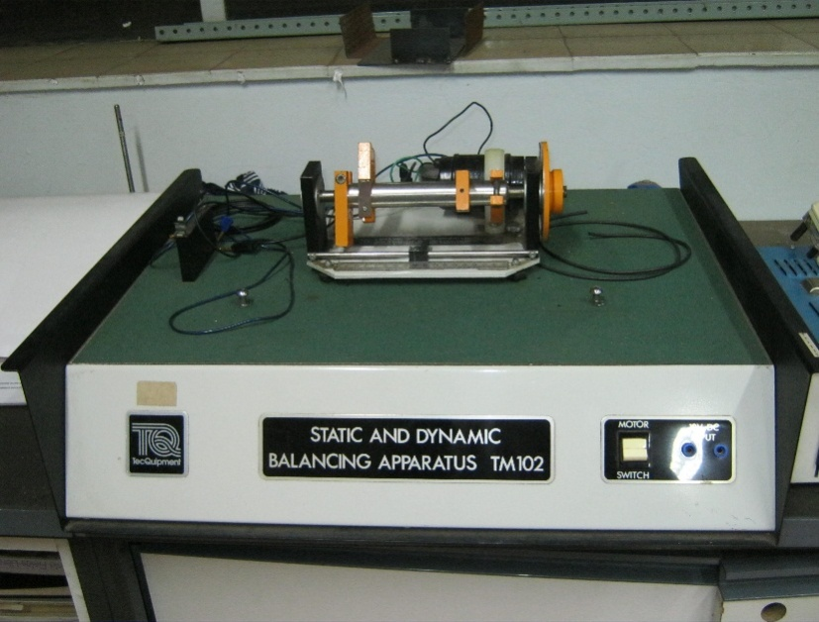

Figure 4.1: Static and Dynamics Balancing Apparatus

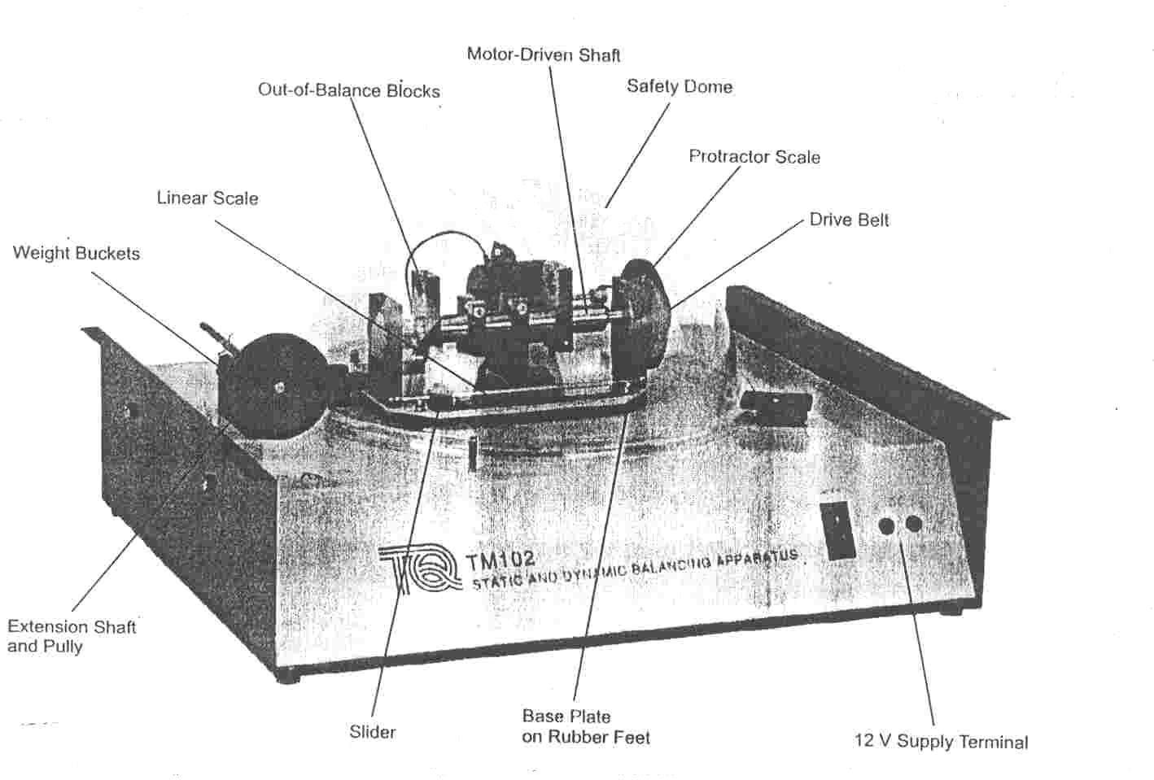

Figure 4.2: TM 102 Static and Dynamic Balancing apparatus with parts labelled.

**THEORY**: Figure 4.2 shows a simple situation where two masses are mounted on a shaft. For static balance;

W1r1 = W2r2 (1)

If there are more than two masses mounted on the shaft in different directions,

For static balance;

W1r1cos α1 = W2r2 cos α2 + W3r3 cos α3  (2)

For experiments using TM 102 apparatus, the product Wr is measured directly for each mass, while the angular positions are determined for static balance either by trigonometry or drawing.

The drawing technique uses the idea that moments can be represented by vectors. The moment vector has a length proportional to the product Wr and is drawn parallel to the direction of the weight from the centre of rotation. If there are more than three masses, the moment figure is a closed polygon.

For dynamic balancing two conditions must be satisfied

1. There must be no out-of-balance centrifugal force trying to deflect the shaft in rotation.
2. There must be no out-of-balance moment or couple trying to twist the shaft in rotation.

For dynamic balancing of three masses distributed along the shaft, the following conditions must be satisfied.

1. central mass at 180o to other two masses
2. masses chosen such that

F2 = F1  + F3 (3)

[F2 corresponds to the central mass)

1. masses distributed along the shaft such that

a2F2 = a3F3 (4)

For a four-mass system

If there are more than three individual masses, similarly the net moment in each plane must be zero if the shaft is to be dynamically balanced.

Horizontal moments about mass (1)

-a2F2cos α2 + a3F3 cos α3 + a4F4 cos α4 = 0 (5)

Vertical moments about mass (1)

a2F2sin α2 + a3F3 sin α3  – a4F4 sin α4 = 0 (6)

F2, F3 and F4 are proportional to W2r2, W3r3 and W4r4

Given the angular positions of two of the masses, the angular positions of the other two can be found by trigonometry or drawing.

**PROCEDURE AND REQUIREMENTS**

**Demonstration of Static Balance by dynamic Imbalance**

1. Remove the Perspex dome and shaft drive-belt.
2. Remove the discs from the four rectangular blocks using the smaller hexagon key.
3. Set up two of the blocks as shown in Figure 3a with a relative angular displacement of 180o and shaft-wise displacement of 120mm. Use the slider to set and read off the positions of the blocks
4. Observe that the shaft will remain in any angular position and is therefore statically balanced.
5. Connect the apparatus to a 12-Volts supply. Make sure that the slider adjacent to the linear scale is clear of the blocks, then replace the shaft drive-belt and the Perspex dome.
6. Briefly run the motor. Note the severe imbalance of the shaft.

**Simple Dynamic Balance Using Four Masses**

1. Remove the Perspex dome and set up the four rectangular blocks as shown in Figure 4.2.
2. Prove theoretically that the shaft is both statically and dynamically balanced.
3. Test the shaft for static balance.
4. Replace the drive-belt and the Perspex dome. Run the motor and observe the lack of vibration, indicating that the shaft is dynamically balanced.

NOTE: THE MOTOR AND ROTATING SHAFT ASSEMBLY IS MOUNTED ON A METAL PLATE WHICH MAY BE CLAMPED DOWN. ENSURE THE PLATE IS FULLY CLAMPED DOWN FOR STATIC BALANCING. FOR DYNAMIC BALANCING, RELEASE THE CLAMP, TURN THROUGH 90o AND LOCK DOWN, LEAVING THE PLATE FREE TO VIBRATE.

**Experimental Determination of the Out-of Balance Moments (Wr)**

1. Remove the Perspex dome and remove the shaft drive belt.
2. Unclip the extension pulley and insert it in the pulley end of the motor driven shaft.
3. Move the apparatus to the edge of the table or bench. Loop two or three turns of the weight bucket cord around the extension pulley. Ensure that there are no obstructions to the movement of the weight buckets.
4. Insert the eccentric disc with the small hole into one of the rectangular blocks. Clamp the block to the shaft such that the protractor scale reading is 0o. Call this block (1).
5. Gradually add the steel balls to one of the weight buckets until the block has moved through 90o. Whilst adding the balls, occasionally tap the shaft mountings to overcome bearing situation.
6. Record the number of balls required to raise the block through 90o. This is proportional to the out-of-balance moment of the block (Wr).
7. Fit an eccentric disc to each block and repeat the above procedure for each block in turn. Enter the results in a table e.g.

Table 4.1: Table of values

|  |  |
| --- | --- |
| BLOCK | Wr (balls) |
| 1 | 88 |
| 2 | 82 |
| 3 | 74 |
| 4 | 64 |

1. Remove the extension shaft and replace it in its mounting clip.

## **EXPERIMENT 5**

# GOVERNORS EXPERIMENT

**TITLE**:   Porter Governor Experiment

**AIM**: Determination of characteristic curve of speed of rotation against sleeve position of Porter Governor and comparison with theory.

**APPARATUS**: TM 127 Governor Apparatus, Porter Governor, Electrical Tachometer,

Control Unit, Meter Rule and Protractor.

**PROCEDURE**:

1. Remove the Perspex dome and screw the governor to the turntable.

(2) Check that the screws are screwed down fully and that the drive belt is correctly located       in the grooves. Replace the dome.

(3) Construct a table of shaft speed (rev/min) against sleeve between zero and 24mm, in        steps of 4mm. Allow two columns for speed readings – one headed “Sleeve rising” the        other “Sleeve falling”.

(4) Set the E64 MKII range selector to 300. Start the motor by turning the speed control and slowly increase the speed until the sleeve just begins to lift. Note the  tachometer reading.

(5) Slowly increase the motor speed until the sleeve rises to the first mark on the shaft. This  is 4mm from the base. Note the tachometer reading. (see note below).

(6) Repeat step 4 for each successive mark on the shaft. Alter the E64 MKII

range if the reading goes off the scale.

(7) When the sleeve is at it’s highest position, decrease the motor speed until the sleeve        just begins to fall. Note the tachometer reading (sleeve falling).

(8) Slow down the motor until the sleeve reaches the next highest mark and note the          tachometer reading. If you should overshoot the mark, increase the speed until the       sleeve rises above the mark then approach the mark again from above.

(9) Repeat step 7 until the sleeve has reached the base.

(10) Read the governor speed corresponding to each sleeve height.

(NOTE: IF THE SLEEVE RISES ABOVE THE MARK YOU ARE AIMING FOR, DO NOT DECREASE THE SPEED SO THAT THE SLEEVE REACHES THE MARK FROM ABOVE. THIS WILL GIVE A FALSE READING DUE TO FRICTION BETWEEN THE SLEEVE AND THE SHAFT. INSTEAD, DECREASE THE SPEED UNTIL THE SLEEVE FALLS BELOW THE APPROPRIATE MARK. THEN INCREASE THE MOTOR SPEED UNTIL THE SLEEVE REACHES THE MARK FROM BELOW)

**CALCULATIONS**:

Assumptions: Refer to Figure 5.1.

1. Equilibrium of the ball, which is subjected to forces of T1, T2, F and mg is assumed
2. Shaft speed is assumed steady.

Let M = mass of sleeve (kg), m = mass of balls (kg), x = sleeve rise (mm),

ω = angular speed (rad/sec).

The vertical component of **T2** is **½Mg** and the horizontal component is **½MgtanΦ**.

The factor **½** occurs because there are two links. **T2** can be found by constructing a triangle of forces for the link.

Taking moments about O.

Fh = mgr + ½ Mgr + ½MgtanΦ . h (1)

F = mrω2 (2)

From Figure 5.1

tan θ = r/h (3)

combining equation (1), (2) and (3)

ω2 = g/h[1 + M/2m(1 + tan Φ/tan θ)] (4)

Using the equation 4 determine ω.

**REQUIREMENTS**:

i) Tabulate your results as follow:

Table 5.1a: Table of results

|  |  |  |
| --- | --- | --- |
| Sleeve Lift (x)  (mm) | Sleeve Rising (N) (rev/min) | Sleeve Falling (N) (rev/min) |
| 0 |  |  |
| 4 |  |  |
| 8 |  |  |
| 12 |  |  |
| 16 |  |  |
| 20 |  |  |
| 24 |  |  |

ii) Measurement H, h, ai (= H-h-xi) and hi (= h-xi) have to be found for a range of sleeve lift, xi either by calculation or drawing. Copy and complete the table below for the theoretical results.

Table 5.1b: Table of results

|  |  |  |  |  |  |  |  |
| --- | --- | --- | --- | --- | --- | --- | --- |
| xi (mm) | cos Φi = ai/65 | tan Φi | cos θ i = h I /85 | tan θ i | ω2 | Ω | N  (rev/min) |
| 0 |  |  |  |  |  |  |  |
| 4 |  |  |  |  |  |  |  |
| 8 |  |  |  |  |  |  |  |
| 12 |  |  |  |  |  |  |  |
| 16 |  |  |  |  |  |  |  |
| 20 |  |  |  |  |  |  |  |
| 24 |  |  |  |  |  |  |  |

iii) Using the same axes, plot the graph of rotational speed N (rev/min) against sleeve lift (mm) for both experimental and theoretical results.

iv) Comment on the graphs.

v) Copy and complete the table below

Table 5.1c: Table of results

|  |  |  |  |  |  |  |
| --- | --- | --- | --- | --- | --- | --- |
| r (mm) | sin Φ = (r-26)/65 | sin θ =  (r-15)/85 | h=  r/ tan θ | cos θ I = h I /85 | xi (mm) | F (N) |
| 50 |  |  |  |  |  |  |
| 55 |  |  |  |  |  |  |
| 60 |  |  |  |  |  |  |
| 65 |  |  |  |  |  |  |
| 70 |  |  |  |  |  |  |
| 75 |  |  |  |  |  |  |

vi) Plot curves of the theoretical speed and controlling force on the same axes as the experimental curves.

vii) Compare the theoretical and experimental curves and explain any differences between them.

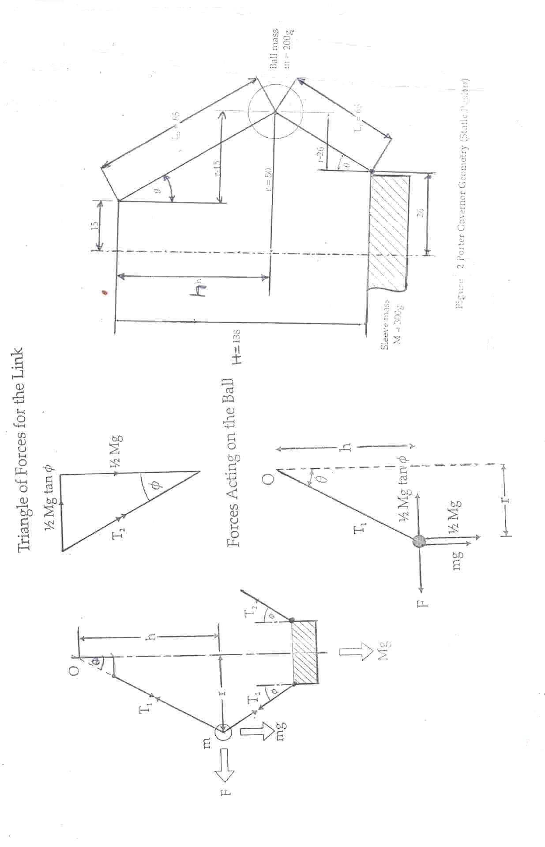

Figure 5.1: Forces acting in the Porter Governor

***PRACTICAL REPORT***

NOTES:

................................................................................................................................................................................................................................................................................................................................................

........................................................................................................................................................................................................................................................................................................................................................................................................................................................................................................................

.................................................................................................................................................................................................................................................................................................................................................................................................................................................................................................

………………………………………………………………………………………………….......................................................…..................................................................................................................................................................……………………………………………………………………………………………………........................................................................................................................................................................................................................……………………………

………………………………………………………………………………………………….......................................................…..................................................................................................................................................................……………………………………………………………………………………………………..............................................................................

……………………………………………………………………………………………………………………………………………………………………………………………………………………………………………………………………………………………………………………………………………………………………………………………………………………………………….......................................................…..................................................................................................................................................................……………………………………………………………………………………………………........................................................................................................................................................................................................................……………………………

………………………………………………………………………………………………….......................................................…..................................................................................................................................................................……………………………………………………………………………………………………........................................................................................................................................................................................................................……………………………

………………………………………………………………………………………………….......................................................…..................................................................................................................................................................……………………………………………………………………………………………………........................................................................................................................................................................................................................……………………………

………………………………………………………………………………………………….......................................................…..................................................................................................................................................................……………

………………………………………………………………………………………........................................................................................................................................................................................................................……………………………

………………………………………………………………………………………………….......................................................…..................................................................................................................................................................……………………………………………………………………………………………………........................................................................................................................................................................................................................……………………………

………………………………………………………………………………………………….......................................................…..................................................................................................................................................................……………………………………………………………………………………………………..............................................................................

………………………………………………………………………………………………….......................................................…..................................................................................................................................................................……………………………………………………………………………………………………........................................................................................................................................................................................................................……………………………

………………………………………………………………………………………………….......................................................…..................................................................................................................................................................……………………………………………………………………………………………………........................................................................................................................................................................................................................……………………………

........................................................................................................................................................................................................................................................................................................................................................................................................................................................................................................................

........................................................................................................................................................................

................................................................................................................................................................................................................................................................................................................................................

........................................................................................................................................................................................................................................................................................................................................................................................................................................................................................................................

.................................................................................................................................................................................................................................................................................................................................................................................................................................................................................................

………………………………………………………………………………………………….......................................................…..................................................................................................................................................................……………………………………………………………………………………………………........................................................................................................................................................................................................................……………………………

………………………………………………………………………………………………….......................................................…..................................................................................................................................................................……………………………………………………………………………………………………..............................................................................

……………………………………………………………………………………………………………………………………………………………………………………………………………………………………………………………………………………………………………………………………………………………………………………………………………………………………….......................................................…..................................................................................................................................................................……………………………………………………………………………………………………........................................................................................................................................................................................................................……………………………

………………………………………………………………………………………………….......................................................…..................................................................................................................................................................……………………………………………………………………………………………………........................................................................................................................................................................................................................……………………………

………………………………………………………………………………………………….......................................................…..................................................................................................................................................................……………………………………………………………………………………………………........................................................................................................................................................................................................................……………………………

………………………………………………………………………………………………….......................................................…..................................................................................................................................................................……………

………………………………………………………………………………………........................................................................................................................................................................................................................……………………………

………………………………………………………………………………………………….......................................................…..................................................................................................................................................................……………………………………………………………………………………………………........................................................................................................................................................................................................................……………………………

………………………………………………………………………………………………….......................................................…..................................................................................................................................................................……………………………………………………………………………………………………..............................................................................

………………………………………………………………………………………………….......................................................…..................................................................................................................................................................……………………………………………………………………………………………………........................................................................................................................................................................................................................……………………………

........................................................................................................................................................................................................................................................................................................................................................................................................................................................................................................................

........................................................................................................................................................................

................................................................................................................................................................................................................................................................................................................................................

........................................................................................................................................................................................................................................................................................................................................................................................................................................................................................................................

.................................................................................................................................................................................................................................................................................................................................................................................................................................................................................................

………………………………………………………………………………………………….......................................................…..................................................................................................................................................................……………………………………………………………………………………………………........................................................................................................................................................................................................................……………………………

………………………………………………………………………………………………….......................................................…..................................................................................................................................................................……………………………………………………………………………………………………..............................................................................

……………………………………………………………………………………………………………………………………………………………………………………………………………………………………………………………………………………………………………………………………………………………………………………………………………………………………….......................................................…..................................................................................................................................................................……………………………………………………………………………………………………........................................................................................................................................................................................................................……………………………

………………………………………………………………………………………………….......................................................…..................................................................................................................................................................……………………………………………………………………………………………………........................................................................................................................................................................................................................……………………………

………………………………………………………………………………………………….......................................................…..................................................................................................................................................................……………………………………………………………………………………………………........................................................................................................................................................................................................................……………………………

………………………………………………………………………………………………….......................................................…..................................................................................................................................................................……………

………………………………………………………………………………………........................................................................................................................................................................................................................……………………………

………………………………………………………………………………………………….......................................................…..................................................................................................................................................................……………………………………………………………………………………………………........................................................................................................................................................................................................................……………………………

………………………………………………………………………………………………….......................................................…..................................................................................................................................................................……………………………………………………………………………………………………..............................................................................

Graph sheet

………………………………………………………………………………………………….......................................................…..................................................................................................................................................................……………………………………………………………………………………………………........................................................................................................................................................................................................................……………………………...***………………………………………………………………………………………………………………………………………………………………………………………………………………………………………………………………………………………………………………***

………………………………………………………………………………………………….......................................................…..................................................................................................................................................................……………………………………………………………………………………………………........................................................................................................................................................................................................................……………………………

………………………………………………………………………………………………….......................................................…..................................................................................................................................................................……………………………………………………………………………………………………........................................................................................................................................................................................................................……………………………

………………………………………………………………………………………………….......................................................…..................................................................................................................................................................……………………………………………………………………………………………………........................................................................................................................................................................................................................……………………………

………………………………………………………………………………………………….......................................................…..................................................................................................................................................................……………………………………………………………………………………………………........................................................................................................................................................................................................................……………………………

………………………………………………………………………………………………….......................................................…..................................................................................................................................................................……………………………………………………………………………………………………........................................................................................................................................................................................................................……………………………

………………………………………………………………………………………………….......................................................…..................................................................................................................................................................……………………………………………………………………………………………………........................................................................................................................................................................................................................……………………………

………………………………………………………………………………………………….......................................................…..................................................................................................................................................................…………….………………………………………………………………………………………........................................................................................................................................................................................................................……………………………

........................................................................................................................................................................................................................................................................................................................................................................................................................................................................................................................

........................................................................................................................................................................

................................................................................................................................................................................................................................................................................................................................................

........................................................................................................................................................................................................................................................................................................................................................................................................................................................................................................................

.................................................................................................................................................................................................................................................................................................................................................................................................................................................................................................

………………………………………………………………………………………………….......................................................…..................................................................................................................................................................……………………………………………………………………………………………………........................................................................................................................................................................................................................……………………………

………………………………………………………………………………………………….......................................................…..................................................................................................................................................................……………………………………………………………………………………………………..............................................................................

……………………………………………………………………………………………………………………………………………………………………………………………………………………………………………………………………………………………………………………………………………………………………………………………………………………………………….......................................................…..................................................................................................................................................................……………………………………………………………………………………………………........................................................................................................................................................................................................................……………………………

………………………………………………………………………………………………….......................................................…..................................................................................................................................................................……………………………………………………………………………………………………........................................................................................................................................................................................................................……………………………

………………………………………………………………………………………………….......................................................…..................................................................................................................................................................……………………………………………………………………………………………………........................................................................................................................................................................................................................……………………………

………………………………………………………………………………………………….......................................................…..................................................................................................................................................................……………

………………………………………………………………………………………........................................................................................................................................................................................................................……………………………

………………………………………………………………………………………………….......................................................…..................................................................................................................................................................……………………………………………………………………………………………………........................................................................................................................................................................................................................……………………………

………………………………………………………………………………………………….......................................................…..................................................................................................................................................................……………………………………………………………………………………………………..............................................................................

………………………………………………………………………………………………….......................................................…..................................................................................................................................................................……………………………………………………………………………………………………........................................................................................................................................................................................................................……………………………

………………………………………………………………………………………………….......................................................…..................................................................................................................................................................……………………………………………………………………………………………………........................................................................................................................................................................................................................……………………………

........................................................................................................................................................................................................................................................................................................................................................................................................................................................................................................................

........................................................................................................................................................................

................................................................................................................................................................................................................................................................................................................................................

........................................................................................................................................................................................................................................................................................................................................................................................................................................................................................................................

.................................................................................................................................................................................................................................................................................................................................................................................................................................................................................................

………………………………………………………………………………………………….......................................................…..................................................................................................................................................................……………………………………………………………………………………………………........................................................................................................................................................................................................................……………………………

………………………………………………………………………………………………….......................................................…..................................................................................................................................................................……………………………………………………………………………………………………..............................................................................

……………………………………………………………………………………………………………………………………………………………………………………………………………………………………………………………………………………………………………………………………………………………………………………………………………………………………….......................................................…..................................................................................................................................................................……………………………………………………………………………………………………........................................................................................................................................................................................................................……………………………

………………………………………………………………………………………………….......................................................…..................................................................................................................................................................……………………………………………………………………………………………………........................................................................................................................................................................................................................……………………………

………………………………………………………………………………………………….......................................................…..................................................................................................................................................................……………………………………………………………………………………………………........................................................................................................................................................................................................................……………………………

………………………………………………………………………………………………….......................................................…..................................................................................................................................................................……………

………………………………………………………………………………………........................................................................................................................................................................................................................……………………………

………………………………………………………………………………………………….......................................................…..................................................................................................................................................................……………………………………………………………………………………………………........................................................................................................................................................................................................................……………………………

………………………………………………………………………………………………….......................................................…..................................................................................................................................................................……………………………………………………………………………………………………..............................................................................

………………………………………………………………………………………………….......................................................…..................................................................................................................................................................……………………………………………………………………………………………………........................................................................................................................................................................................................................……………………………

........................................................................................................................................................................................................................................................................................................................................................................................................................................................................................................................

........................................................................................................................................................................

................................................................................................................................................................................................................................................................................................................................................

........................................................................................................................................................................................................................................................................................................................................................................................................................................................................................................................

Graph sheet

........................................................................................................................................................................................................................................................................................................................................................................................................................................................................................................................

.................................................................................................................................................................................................................................................................................................................................................................................................................................................................................................

………………………………………………………………………………………………….......................................................…..................................................................................................................................................................……………………………………………………………………………………………………........................................................................................................................................................................................................................……………………………

………………………………………………………………………………………………….......................................................…..................................................................................................................................................................……………………………………………………………………………………………………..............................................................................

……………………………………………………………………………………………………………………………………………………………………………………………………………………………………………………………………………………………………………………………………………………………………………………………………………………………………….......................................................…..................................................................................................................................................................……………………………………………………………………………………………………........................................................................................................................................................................................................................……………………………

………………………………………………………………………………………………….......................................................…..................................................................................................................................................................……………………………………………………………………………………………………........................................................................................................................................................................................................................……………………………

………………………………………………………………………………………………….......................................................…...................